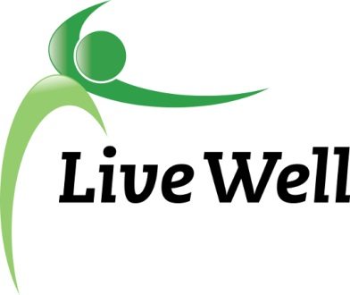
AGENDA

Healthy Food for All Work Group

Lawrence Public Library, Meeting Room A, KS 66044-3701, United States

10:00am – 11:30am, Wednesday, January 10th, 2017

Agenda items | Notes | Action Items
- Introductions | - Share agency accomplishment pertaining to HFFA work. Include:  - Who, what, where, when, any partners, number of participants, description
- Announcements | - New Mission: ““Leading a movement to build communities that support the health and well-being of all.”  - Meeting time change  - NationBuilder- Update  - Community Health Assessment- Update:  - Access to healthy food and physical activity  - Behavioral health  - Poverty and lack of good-paying jobs  - Safe and affordable housing
- Subcommittee Break out session (30 minutes)  Pantry: Sue, Christina, Jessica, Connie, Gwen, Liz  Corner stores: Michelle, Helen, Melissa, Kelsey, Brooke | Points of Discussion:  - Continued work on projects  - Intern projects-submit to Kelsey  - Action items moving forward-Specific assignments.
- Subcommittee report to group | Small report back on discussion and action steps
- Additional updates | - Announcements for the group  - Meeting location for next meeting?
- Adjourned

